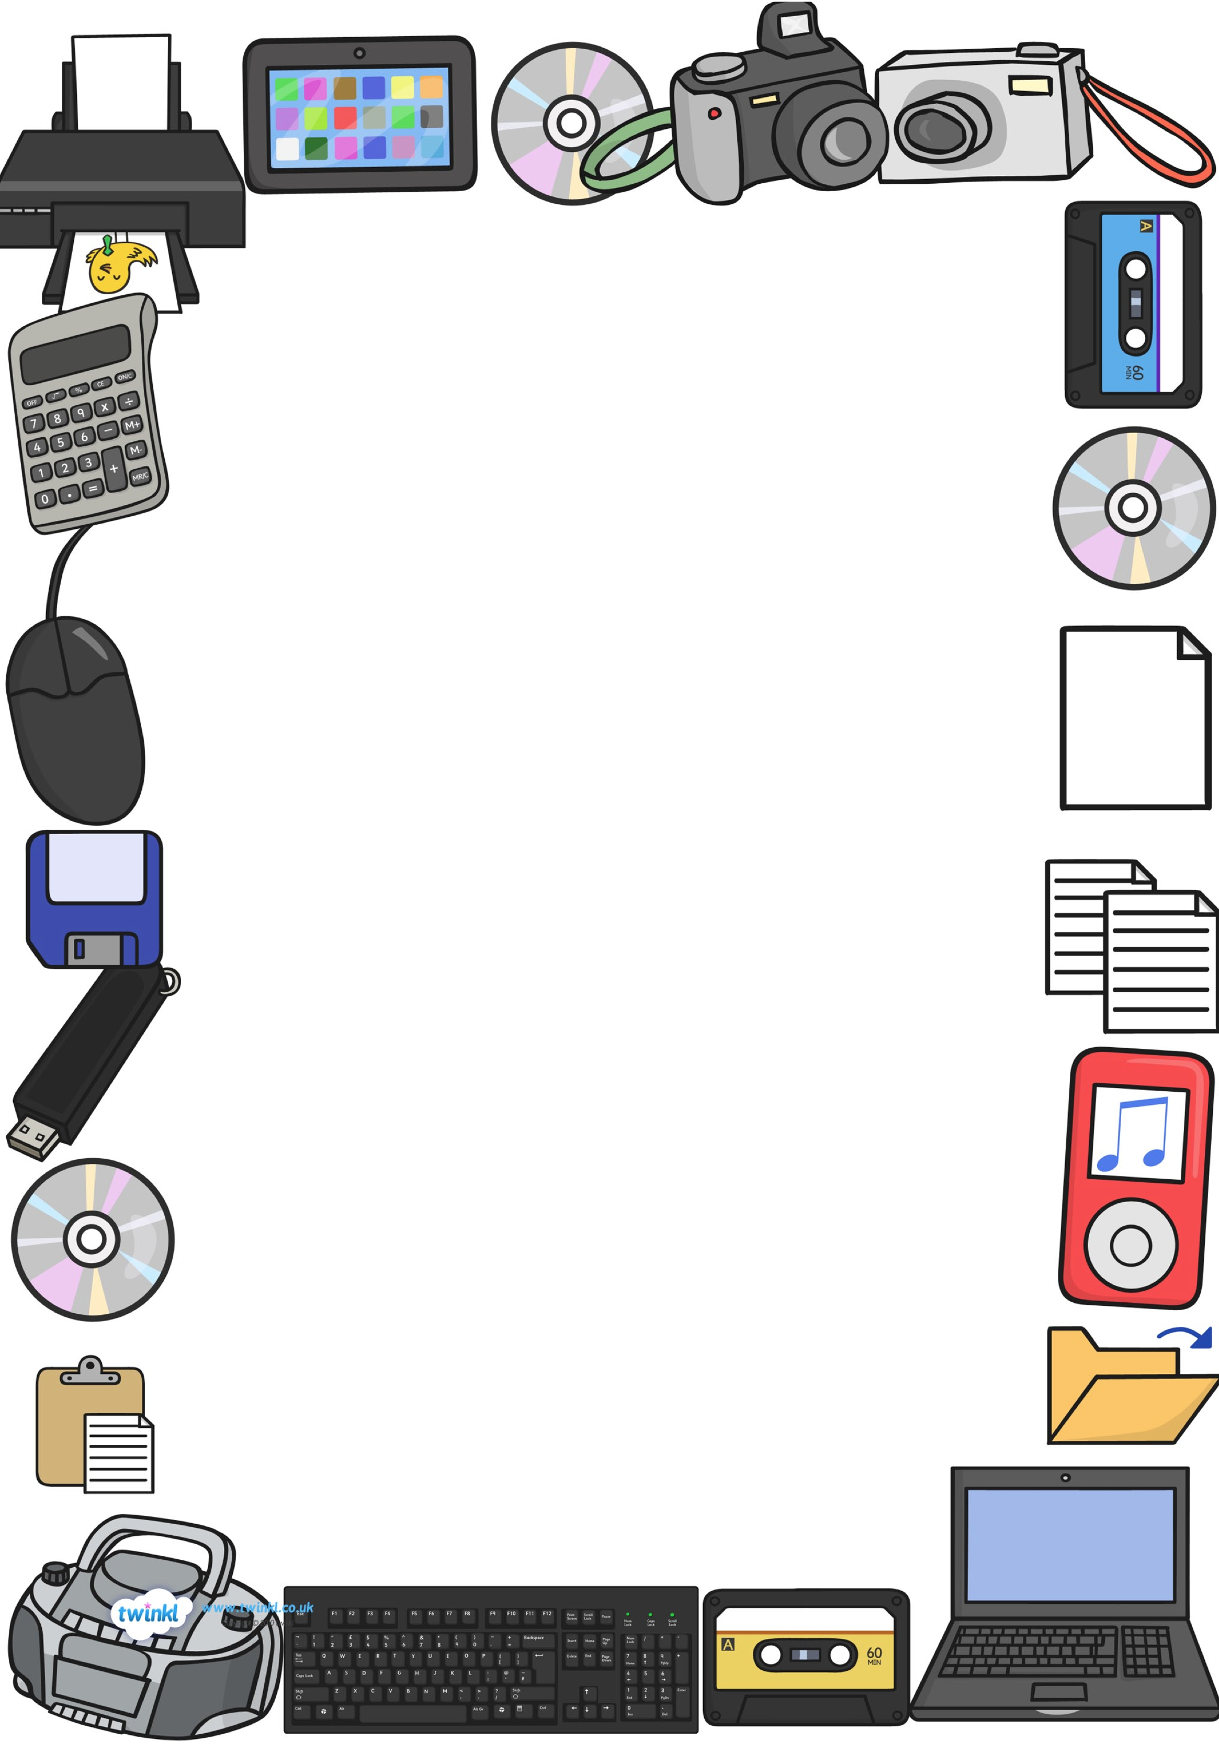
Pioneer of Technology Newsletter
Instructions:
Research the Internet for information about your pioneer of technology Find images related to each topic. Use your images and research information to create an interesting and informative newsletter.
- Childhood
  - Birth Date
  - Birth Place
  - Education
  - Family Background
  - Important Events in Childhood

- Adult Life
- Marriage and/or Children
- College Education
- Important Events in Early Career

- Important Technological Contributions
- Awards or Recognitions
- How (Pioneer) Changed Society

Please complete the chart below
Childhood
Birth date
Birth Place
Education
Family Background
Important Events in Childhood

Adult Life
Marriage and/or Children
College Education
Important Events in Early Career

Important Technological Contributions

Awards or Recognitions

How this (Person) Changed Society

Rubric
Category | Points | Points Earned
Birth date | 5
Birth place | 5
Education | 5
Family | 5
Important Events in Childhood | 5
Marriage and/or Family | 5
College Education | 5
Important Events in Early Career | 10
Important Technological Contributions | 40
Awards or Recognitions | 10
How This (Person) Changed Society | 5
Total

Due Date: ________________________________________

