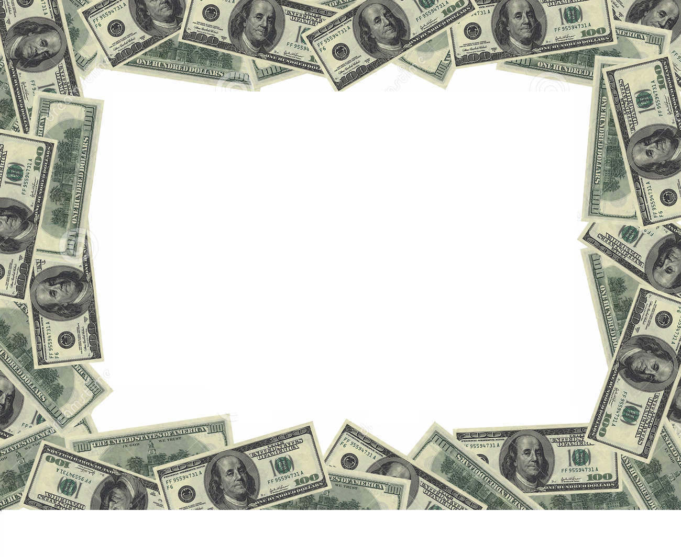

$$ Million Dollar Project $$
You have just received $1,000,000 and you must spend it – every last penny. That doesn’t sound so hard, does it? You can buy cars, computers, trips, etc. Now is your chance to buy everything your heart desires, just follow the guidelines below:
- You need to spend $1,000,000 exactly, no more, no less.
- You must buy at least ten (10) items, but you cannot buy more than thirty (30).
- No single item can cost more than $500,000.00. If you are considering purchasing a home you may want to compare prices of homes in other states and consider moving out-of-state.
- You may not buy more than one house, one car, or two forms of transportation.

Completion of the project will include two things:
(1) Expense Folder
(2) Microsoft Excel Chart

- Expense Folder

  - Calculate your Expenses: Show how you spent your money by filling in the EXPENSE TABLE given to you. It should list what you purchased, the cost of the item you purchased, and a line-by-line cumulative record of your balance.
  - Proof of Item’s Cost: You must prove the cost of the items you purchase; don’t just guess or write down any price you make up. Write the exact amount on the expense table and Print the Internet ad that shows your item’s cost. Number the pages and record the page number on your expenditure sheet next to the listed item.

- Microsoft Excel Chart
Visual display: Use data from the EXPENSE TABLE to create a chart on Microsoft Excel. Several types of charts (bar, line, and pie) must be used

Expense Table
Item | Item Purchased | Item’s Cost | Current Balance | Page Number
 | Write the name of the item you bought in this column | Beginning Balance  Record the item’s cost in this column | Subtract your item’s cost and record the amount you have left to spend here | Enter the page number of your proof of cost page
1
2
3
4
5
6
7
8
9
10
Item | Item Purchased | Item’s Cost | Current Balance | Page Number
 | Write the name of the item you bought in this column | Beginning Balance  Record the item’s cost in this column | Subtract your item’s cost and record the amount you have left to spend here | Enter the page number of your proof of cost page
11
12
13
14
15
16
17
18
19
20

Example of “Expense Folder”
Page 1

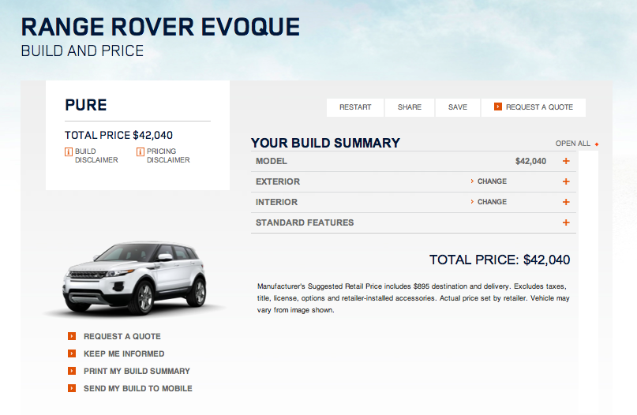
Item Purchased

Page Number

Item’s Cost

Expense Table

Item | Item Purchased | Item’s Cost | Current Balance | Page Number
 | Write the name of the item you bought in this column | Beginning Balance  Record the item’s cost in this column | Subtract your item’s cost and record the amount you have left to spend here | Enter the page number of your proof of cost page
1 | Range Rover Evoque | $42,040 | $ 1,000,000 - $42,040  = $957,960 | 1

Example of “Expense Folder”
Page 2
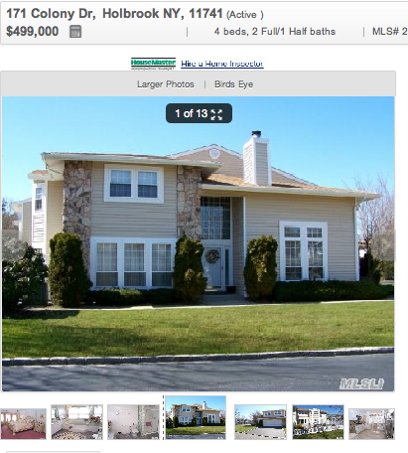
Item’s Cost

Item Purchased

Expense Table
Item | Item Purchased | Item’s Cost | Current Balance | Page Number
1 | Range Rover Evoque | $42,040 | $ 1,000,000 - $42,040  = $957,960 | 1
2 | 171 Colony Dr.  Holbrook, NY | $499,999 | $957,960 - $499,999= $457,961 | 2

